**SoftUni OOP Game Contest**

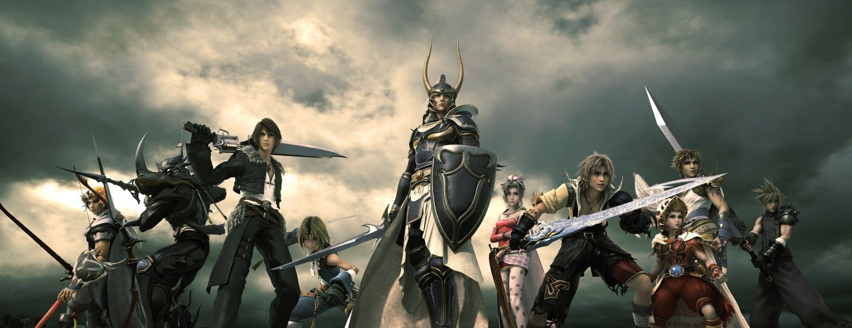

SoftUni is organizing a contest for the best role playing game from the OOP teamwork projects. The winning teams will receive a grand prize!

The game should be:

Item1